Courses

Courses are the spaces on Moodle where [teachers](https://docs.moodle.org/31/en/Teacher) add learning materials and activities for their students. Courses may be created by [admins](https://docs.moodle.org/31/en/Administrator), [course creators](https://docs.moodle.org/31/en/Course_creator) or [managers](https://docs.moodle.org/31/en/Manager). Teachers can then add the content and re-organise them according to their own needs.

# Module: Course Sections

Courses can be divided into sections to organize resources and activities for students. Each section can have a description and can contain many activities and resources as the teacher desires.

## Feature: Editing sections

Below is an example of a topic section as seen by the teacher in edit mode.

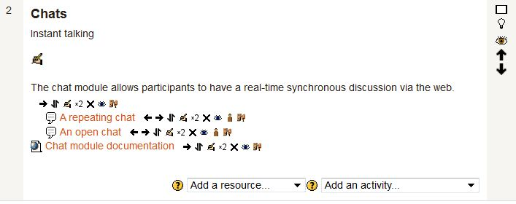

Section seen by teacher with edit turned on, showing edit icons

In edit mode, sections can be moved, hidden from students, highlighted or turned on (section edit icons), plus given titles in the section description area. Also in edit mode it is possible to move [activity](https://docs.moodle.org/20/en/Activity_modules) or [resource](https://docs.moodle.org/20/en/Resources) in the course, plus delete, hide or edit their settings by using the activity edit icons.

## Feature: Editing sections > Hiding sections

Note that sections can be easily hidden using the  eyeball icon. There is a course setting that specifies whether or not these hidden sections are entirely invisible to student/participants, or just show as a horizontal block that says it is unavailable. Such sections will always be fully available (but will appear greyed out) to teacher/administrators of the course.

# Problem

Suppose you want to use the feature: Hiding Sections, in order to hide sections for some users based on a specific field value or restriction set. For example, you could have 2 conditions, one based on date (with eye shut) and one based on completing a previous activity (with eye open). That way, the activity will not appear at all until the date; then it will appear, but tell you that you need to complete the other activity; then when you complete the other activity you can access it.

Write a feedback to request this functionality from the development team.